Input Funnel Help Documentation

Introduction
This document describes the style and content of the Help file to be included with the UCLID Input Funnel delivery. Source documentation will include:
- UCLID Input Funnel API Reference
- UCLID Input Funnel Coclass Reference
- Tutorial Instructions (9 documents for 10 tutorials)
- Class Diagrams
I am not sure yet how the class diagrams should be integrated.

General Description
The basic style of the Help file will be similar to the ARCObjects Help file. The main page is shown below. The relevant details visible on this screenshot include the main page and the index page. The index page is a collection of items some of which have subitems.

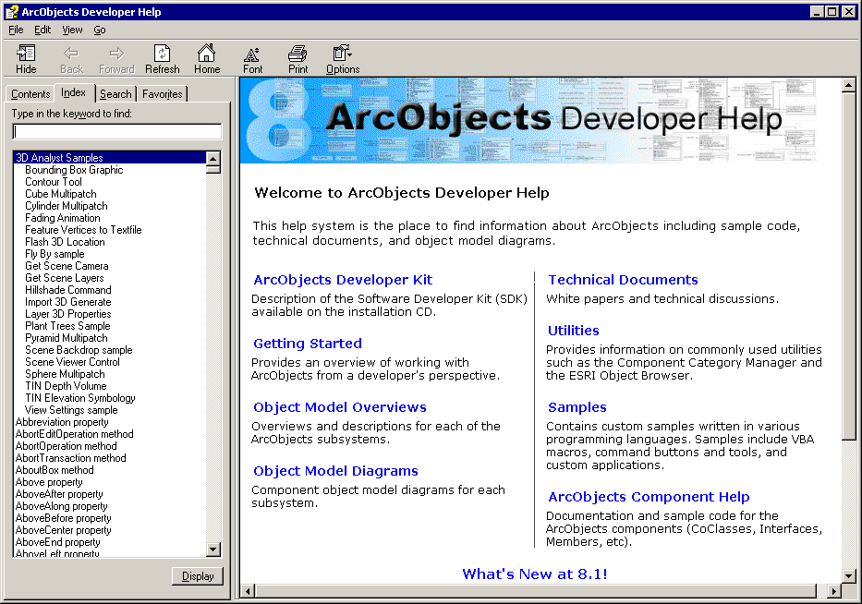

The topics for the Input Funnel main page will be as follows. I’m not sure yet what will be displayed as descriptions for each of the topics or for the topics’ pages.
- Interfaces
- Coclasses
- Tutorials
- Class Diagrams

Interfaces
The general source for the interfaces will be the API Reference. Each interface should be a topic in the Help index with a subtopic for each method and property. The main page for each interface will follow the pattern below.

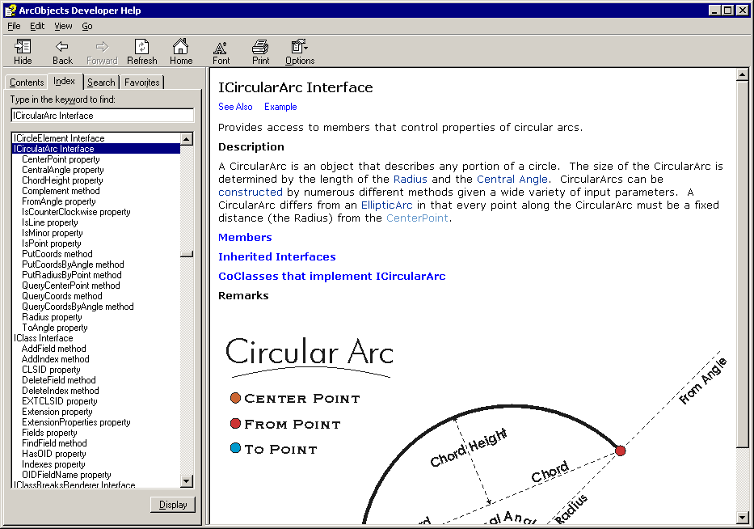

- The See Also section provides a popup dialog with links to related interfaces. Most of the Input Funnel interfaces will not need these links. The interfaces requiring See Also will be listed.

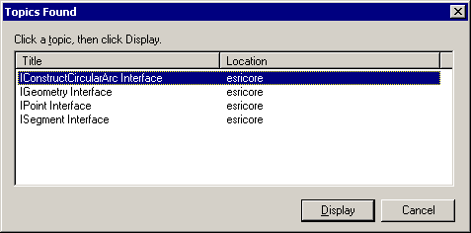

- The Example section shows a source code example for using the interface. For the Input Funnel, the Example link will provide a popup dialog with links to relevant Tutorial instructions. If only one tutorial is relevant to the interface, the link will go directly to the tutorial document. If no tutorials are relevant, the Example link is not needed.

- The Description section will be taken directly from the API Reference document. Each interface has a description immediately after the table describing object type, defined in, and implementation classes. The description should be the first paragraph if multiple paragaphs are present. The remaining paragraphs will be under Remarks.

- The Members section is an alphabetical list of methods and properties for the interface. The combo box can be replaced by a Name label.

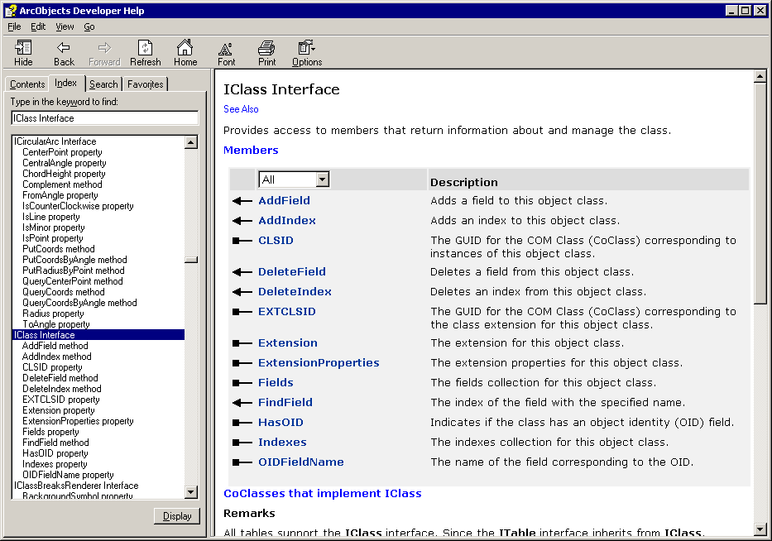

- The Inherited Interfaces section will be removed.

- The Coclasses section will be taken directly from the API Reference. Each interface includes a group of implementation classes.

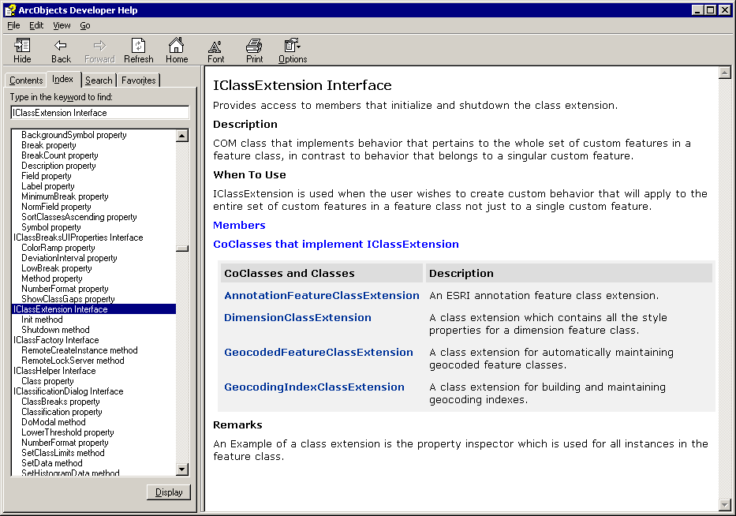

- The Remarks section will usually be empty. Specific interfaces that need this section will be indicated in a later section of this document. The remarks are expected to be the second and any other following paragraphs before the collection of methods.

Coclasses
The general source for the coclasses will be the Coclass Reference. The main page for each coclass will follow the pattern below.

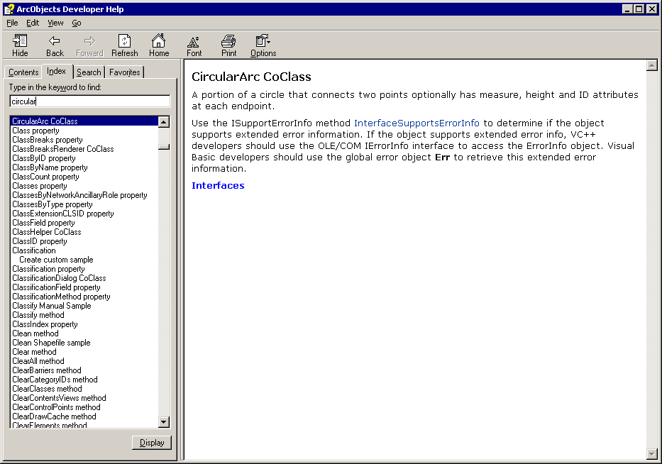

- The Description section will be taken directly from the Coclass Reference. Each coclass has a short description after the implementation details.

- The Interfaces section will be taken directly from the Coclass Reference. Each coclass includes a list of implemented interfaces.

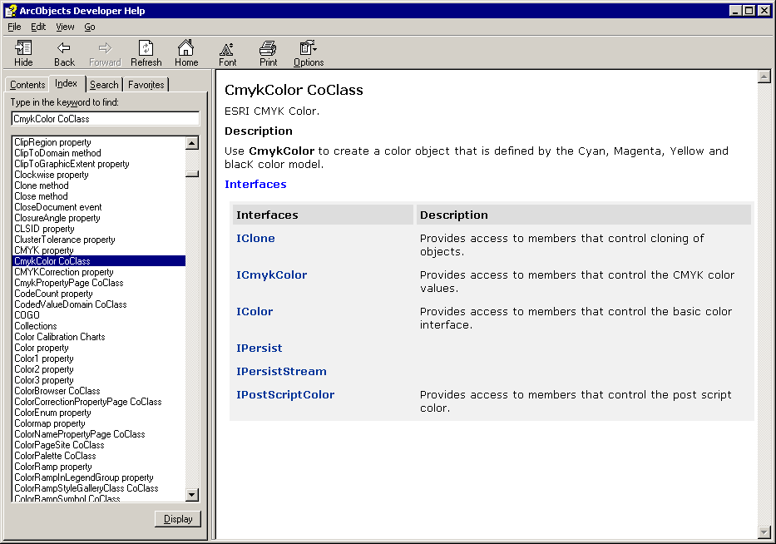

Methods
The general source for the methods will be the API Reference. The main page for each method will follow the pattern below.

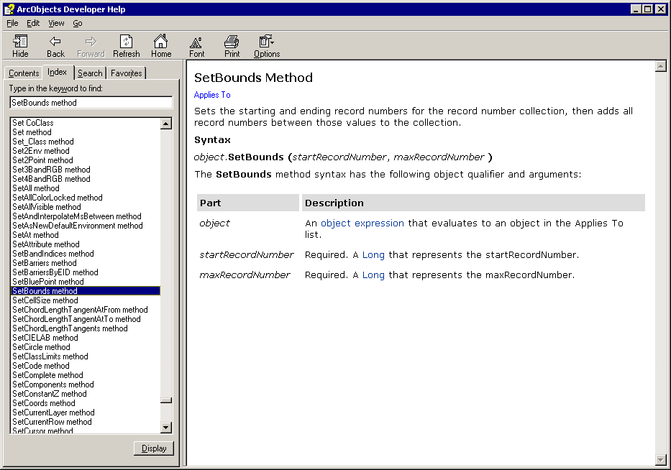

- The Description section will be taken directly from the API Reference. Use the entire table as the description.

- The Applies To label will link to the parent interface.

- The Syntax section will be removed. The parameter names and descriptions are included in the table.

Properties
The general source for the properties will be the API Reference. The main page for each property will follow the pattern below.

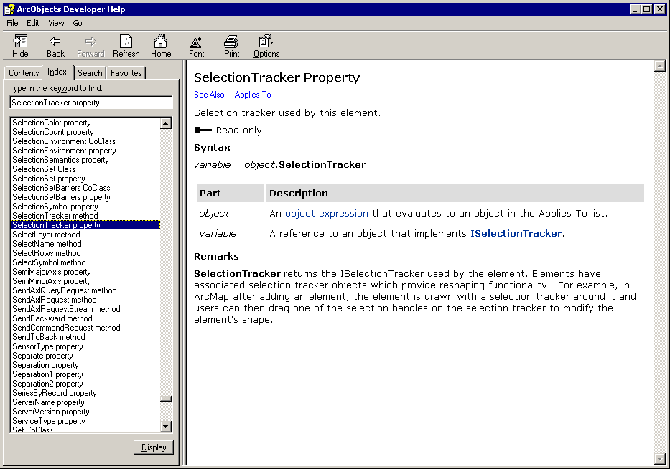

- The Description section will be taken directly from the API Reference. Use the Type and Description rows of the table.

- The read-only indication will be taken directly from the API Reference. Use the Access row of the table.

- The See Also link will not be used. An Example link may be present. Properties that need an Example link will be noted later.

- The Applies To link will connect to the associated interface page.

- The Remarks section will usually be empty. Specific properties that need this section will be indicated in a later section of this document.

Examples
The source for the examples will be the collected Tutorial Instructions. The main page for each example will be the beginning of the associated tutorial. Later paragraphs in this section will suggest index topics that link to specific tutorial documents. The topics should be listed in the index both individually and as subentries under Examples. Note that topics with multiple links should display a dialog box for further selection from the user.

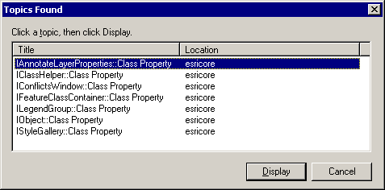

- The Tutorial entry in the index will have ten subentries, one for each tutorial. Each subentry will link to the beginning of the associated document except for TutorialVB5 which does not have separate instructions. The link for TutorialVB5 will be the Testing the Input Validator heading within TutorialVB4.doc. The subentries for the Tutorials index entry should be:
  - Visual Basic #1
  - Visual Basic #2
  - Visual Basic #3
  - Visual Basic #4
  - Visual Basic #5
  - Visual Basic #6
  - Visual C++ #1
  - Visual C++ #2
  - Visual C++ #3
  - Visual C++ #4

- Examples that link to TutorialVB1.
  - Highlighted Text Window
  - Input Funnel
  - Spot Recognition Window

- Examples that link to TutorialVB2.
  - Distance object
  - DistanceConverter object
  - Highlighted Text Window
  - Input Funnel
  - Spot Recognition Window

- Examples that link to TutorialVB3.
  - Input Funnel
  - Input Receiver

- Examples that link to TutorialVB4.
  - Input Funnel
  - Input Validator

- Examples that link to TutorialVB5. Note that this link will be the Testing the Input Validator heading within TutorialVB4.doc.
  - Highlighted Text Window
  - Input Funnel
  - Input Validator
  - Spot Recognition Window

- Example that links to TutorialVB6.
  - Exception Handling

- Examples that link to TutorialVC1.
  - Bearing object
  - Distance object
  - Highlighted Text Window
  - Spot Recognition Window

- Examples that link to TutorialVC2.
  - Bearing object
  - Distance object
  - Highlighted Text Window
  - Input Funnel
  - Input Validator
  - Spot Recognition Window

- Examples that link to TutorialVC3.
  - Exception Handling

- Examples that link to TutorialVC4.
  - Highlighted Text Window
  - Input Finder
  - Input Funnel

See Also Links for Interfaces
The following interfaces need See Also entries on their main pages. The links will be as specified.
  - ICategorizedComponentInfo – See Also link to IIUnknownVector
  - IHighlightedTextWindowPTH – See Also link to ISpotRecognitionWindow
  - IInputEntity – See Also link to IInputEntityManager
  - IInputEntityManager – See Also link to IInputEntity
  - IInputReceiver – See Also link to IIREventHandler
  - IIREventHandler – See Also link to IInputReceiver
  - ILineTextEvaluator – See Also links to ICPenIR and ISpotRecognitionWindow
  - IParagraphTextCorrector – See Also link to ISpotRecognitionWindow
  - ISRWEventHandler – See Also link to ISpotRecognitionWindow

Example Links for Interfaces
The following interfaces need Example entries on their main pages. The links will be as specified.
  - IBearing – Examples links to TutorialVC1, TutorialVC2
  - ICartographicPoint – Examples link to TutorialVC2
  - ICategorizedComponent – Examples link to TutorialVC4
  - ICOMUCLIDException – Examples links to TutorialVB6, TutorialVC3
  - IDistance – Examples links to TutorialVC1, TutorialVC2
  - IDistanceConverter – Examples link to TutorialVC2
  - IHighlightedTextWindow – Examples links to TutorialVB1, TutorialVB2, TutorialVC2, TutorialVC4
  - IInputEntity – Examples links to TutorialVB1, TutorialVB2, TutorialVB3, TutorialVB4, TutorialVB6, TutorialVC2
  - IInputValidator – Examples links to TutorialVB2, TutorialVB4, TutorialVC2
  - ISpotRecognitionWindow – Examples links to TutorialVB1, TutorialVB2, TutorialVC2
  - ITextInput – Examples links to TutorialVB1, TutorialVB2, TutorialVB3, TutorialVB4, TutorialVB6, TutorialVC2

Remarks Links for Interfaces
The following interfaces need Remarks entries on their main pages. The details will be as specified.
  - IHighlightedTextWindow – the paragraph starting “The basic operation…”
  - IInputEntity – the last two paragraphs starting “Whenever an input receiver…”
  - ILineTextCorrector – the last two paragraphs starting “Implement this interface…”
  - ILineTextEvaluator – the paragraph starting “The higher the score…”
  - IParagraphTextCorrector – the paragraph starting “The implementation of this interface…”

Examples Links for Properties
The following properties need Examples entries on their main pages. The details will be as specified.
  - None at this time

Remarks Links for Properties
The following properties need Remarks entries on their main pages. The details will be as specified.
  - None at this time

